"The throttle control *(rod)* end—threaded for a rod-end—came off the control *(rod)*," says this submitter*.* "It appears to have been swaged on to the end of the *(now separated)* control *(rod)*." *(P/N: 1023890103. Are you saying this rod end was—or was not suppose to have been swaged in the first place? Ed.)*

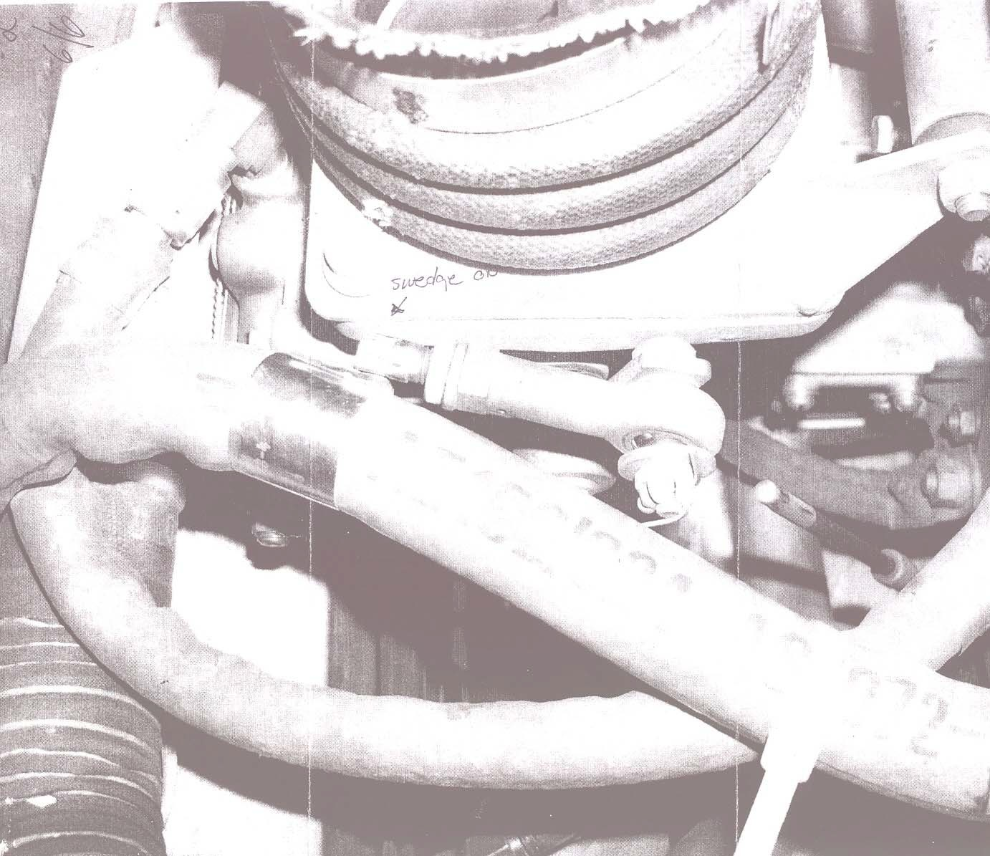

Part Total Time: 1,275.00 Hours